Chapter 8
Maintaining Security
About This Chapter
In this chapter, you’ll learn how to control access to your Web application using the three techniques that Microsoft ASP.NET provides for identifying users and allowing them to have access to your application. You’ll also learn how to secure data transmitted across the Internet so that others can’t read it.
This chapter does not provide a comprehensive guide to server or network security. That is truly a broad subject involving a great deal of conceptual and system-specific information. What this chapter does provide is a practical guide to implementing Web application security through ASP.NET.
Before You Begin
To complete the lessons in this chapter, you must:
- Have access to two computers in a Microsoft Windows network. This can be a simple workgroup-based network such as you might set up at home, but a domain-based network is best.
- Have Administrator privileges on a computer that functions as a server on the network.
If you don’t have access to a Windows network, you can perform most of the tasks in this chapter using a single computer and running the applications locally, as you do in Microsoft Visual Studio’s Debug mode. However, you will not be able to easily test authentication of multiple users.
Lesson 1: Authenticating and Authorizing Users
Authentication is the process of identifying users. Authorization is the process of granting access to those users based on identity. Together, authentication and authorization provide the means to keeping your Web application secure from intruders.
In this lesson, you’ll learn how ASP.NET handles anonymous users, and you’ll get an overview of the different ways you can identify and authorize users. This information will help you choose an authentication strategy based on the type of application you are creating.
After this lesson, you will be able to
- Describe how ASP.NET grants access to users who are not authenticated and how those users appear within Windows security tools
- Choose an authentication method based on your application’s needs
- Add HTML pages to the list of file types that will be included with your application’s authentication and authorization settings
Estimated lesson time: 10 minutes
Access by Anonymous Users
Anonymous access is the way most public Web sites work—sites containing public information allow anyone to see that information, so they don’t authenticate users. ASP.NET Web applications provide anonymous access to resources on the server by impersonation. Impersonation is the process of assigning a user account to an unknown user.
By default, the anonymous access account is named IUSER_machinename. You use that account to control anonymous users’ access to resources on the server.
To see or change the access privileges to the anonymous access account, use the Windows Computer Management snap-in as described in the following steps:
- Log on to the server as the computer administrator.
- From the Start menu, choose Administrative Tools, and then choose Computer Management to run the Computer Management console, as shown in Figure 8-1.
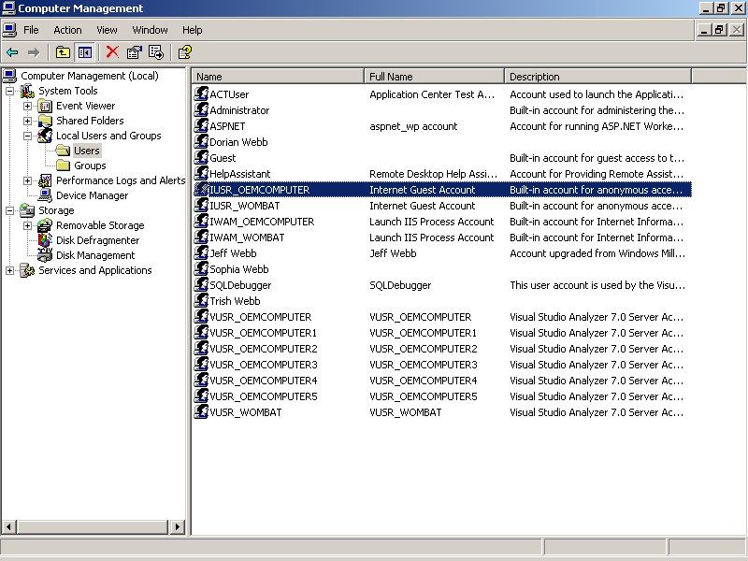
Figure 8-1. Viewing users
- From the list on the left, choose Local Users And Groups, and then select the Users folder to display the list of authorized users for this computer.
- From the user list on the right, double-click the anonymous user account named IUSR_computername. The Computer Management console displays the account’s properties, as shown in Figure 8-2.
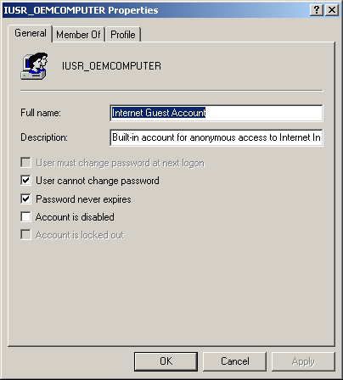
Figure 8-2. Properties of the anonymous access account
- Click the Member Of tab to view the user groups the account belongs to. By default, anonymous users belong to the Guests group, which has limited privileges.
Under the default settings, ASP.NET uses the ASPNET account to run the Web application. This means that if the application attempts to perform any tasks that are not included in the ASPNET account’s privileges, a security exception will occur and access will be denied. The account name will also show up in the security event log of the event viewer, as shown in Figure 8-3.
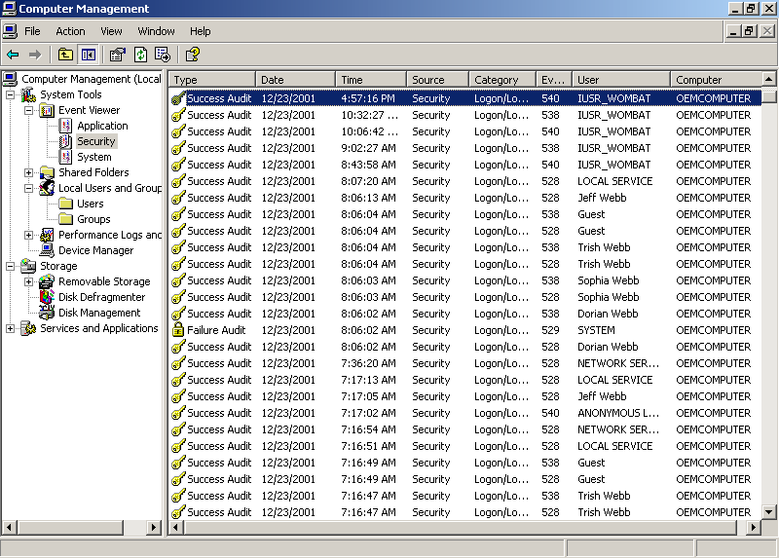
Figure 8-3. The security event log in the Computer Management console
You restrict the access of anonymous users by setting Windows file permissions. To be secure, your server must use the Microsoft Windows NT file system (NTFS). The earlier FAT or FAT32 file systems do not provide file-level security. For more information about setting Windows file permissions, see the Windows security Help topics.
Access by Authenticated Users
As stated earlier, anonymous access is fine for public information. But if your application contains private information or performs restricted tasks such as placing orders, you will want to authenticate and authorize individual users.
There are three major ways to authenticate and authorize users within an ASP.NET Web application:
- Windows authentication
Identifies and authorizes users based on the server’s user list. Access to resources on the server is then granted or denied based on the user account’s privileges. This works the same way as regular Windows network security.
- Forms authentication
Directs users to a logon Web form that collects user name and password information, and then authenticates the user against a user list or database that the application maintains.
- Passport authentication
Directs new users to a site hosted by Microsoft so that they can register a single user name and password that will authorize their access to multiple Web sites. Existing users are prompted for their Microsoft Passport user name and password, which the application then authenticates from the Passport user list.
Each of these approaches, along with anonymous access, has different advantages. These authentication methods are best suited for different types of Web applications, as summarized in Table 8-1.
Table 8-1. Web Application Types and Authentication Techniques
Application type | Use this type of authentication | Description
Public Internet Web application | Anonymous | This is the common access method for most Web sites. No logon is required, and you secure restricted resources using NTFS file permissions.
Intranet Web application | Windows authentication | Windows authentication authenticates network users through the domain controller. Network users have access to Web application resources as determined by their user privileges on the server.
Private corporate Web application | Windows authentication | Corporate users can access the Web application using their corporate network user names and passwords. User accounts are administered using the Windows network security tools.
Commercial Web application | Forms | Applications that need to collect shipping and billing information should implement Forms authentication to gather and store customer information.
Multiple commercial Web applications | Passport | Passport authentication allows users to sign in once through a central authority. The user’s identity is then available to any application using the Passport SDK. Customer information is maintained in a Passport profile, rather than in a local database.
Windows, Forms, and Passport authentication uses the classes found in the System.Web.Security namespace. To use these classes in your code, you should add an Imports statement (Visual Basic .NET) or a using statement (Visual C#) at the beginning of each module that performs authentication, as shown here:
Visual Basic .NET
Imports System.Web.Security
Visual C#
using System.Web.Security
The following sections describe how to authenticate and authorize users using each of the three techniques.
Using Authentication with HTM and HTML Files
The three ASP.NET authentication modes apply to files that are part of the Web application. That includes Web forms (.aspx), modules (.asax), and other resources that are processed through the Web application’s executable. It does not automatically include HTML pages (.htm or .html). Those pages are handled by Internet Information Services (IIS), rather than ASP.NET. If you want to authenticate users who access HTML pages from within your Web application using Windows, Forms, or Passport authentication modes, you must map those files to the ASP.NET executable.
To map .htm and .html files to the ASP.NET executable using the IIS snap-in, follow these steps:
- In the IIS snap-in, select the folder containing your Web application, and then choose Properties from the Action menu. IIS displays the Properties dialog box.
- Click the Home Directory or Virtual Directory tab, and then click Configuration. IIS displays the Application Configuration dialog box, as shown in Figure 8-4.
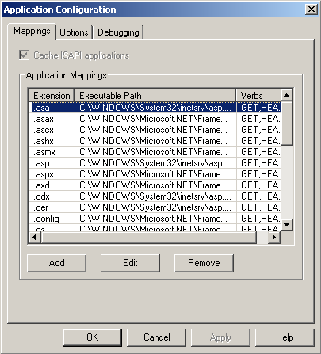
Figure 8-4. The Application Configuration dialog box
- Click Add. IIS displays the Add/Edit Application Extension Mapping dialog box, as shown in Figure 8-5.
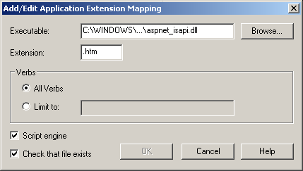
Figure 8-5. The Add/Edit Application Extension Mapping dialog box
- Click Browse, and select the aspnet_isapi.dll file. That file is stored in the Windows Microsoft .NET Framework directory; the path will be something like C:\Windows\Microsoft.NET\Framework\versionnumber\aspnet_isapi.dll.
- Type .htm in the File Extension box, and click OK.
- Repeat steps 3 through 5 for the .html file extension. Click OK to close the IIS dialog boxes when you’ve finished.
Lesson 2: Using Windows Authentication
Windows authentication uses the security features integrated into the Windows NT and Windows XP operating systems to authenticate and authorize Web application users. The advantage of Windows authentication is that your Web application can use the exact same security scheme that applies to your corporate network—user names, passwords, and permissions are the same for network resources and Web applications.
After this lesson, you will be able to
- Activate Windows authentication in your Web application
- Allow or deny access to your application based on the user’s name or role in your organization
- Identify users within your application once they have logged on
- Use IIS settings to provide other forms of authentication
- Run code under the identity of the Web application user
- Run code under a specific identity
Estimated lesson time: 20 minutes
Enabling Windows Authentication
Windows authentication is the default authentication method when you create a new Web application project.
To see how Windows authentication works, follow these steps:
- Create a new Web application project. For a Microsoft Visual Basic .NET project, change the <authorization> element in the Web.config file to appear as follows. For a Microsoft Visual C# project, add the following <authorization> element:
- <authorization>
- <deny users="?" />
</authorization>
- Add the following HTML table definition to the project’s startup Web form:
- <TABLE id="tblUser">
- <TR>
- <TD>Authenticated</TD>
- <TD><SPAN id="spnAuthenticated" runat="server"></SPAN></TD>
- </TR>
- <TR>
- <TD>User name</TD>
- <TD><SPAN id="spnUserName" runat="server"></SPAN></TD>
- </TR>
- <TR>
- <TD>Authentication type</TD>
- <TD><SPAN id="spnAuthenticationType" runat="server"></SPAN></TD>
- </TR>
</TABLE>
- Switch the Web form to Design view, and add the following code to the startup Web form’s code-behind module:
Visual Basic .NET
' Add at module-level.
Imports System.Web.Security

Private Sub Page_Load(ByVal sender As System.Object, _
ByVal e As System.EventArgs) Handles MyBase.Load
spnAuthenticated.InnerText = User.Identity.IsAuthenticated
spnUserName.InnerText = User.Identity.Name
spnAuthenticationType.InnerText = User.Identity.AuthenticationType
End Sub
Visual C#
// Add at module-level.
using System.Web.Security;

private void Page_Load(object sender, System.EventArgs e)
{
spnAuthenticated.InnerText = User.Identity.IsAuthenticated.ToString();
spnUserName.InnerText = User.Identity.Name;
spnAuthenticationType.InnerText = User.Identity.AuthenticationType;
}
- Run the project.
When the project runs locally, ASP.NET will authenticate you using the name that you used to log on to Windows, as shown in Figure 8-6.
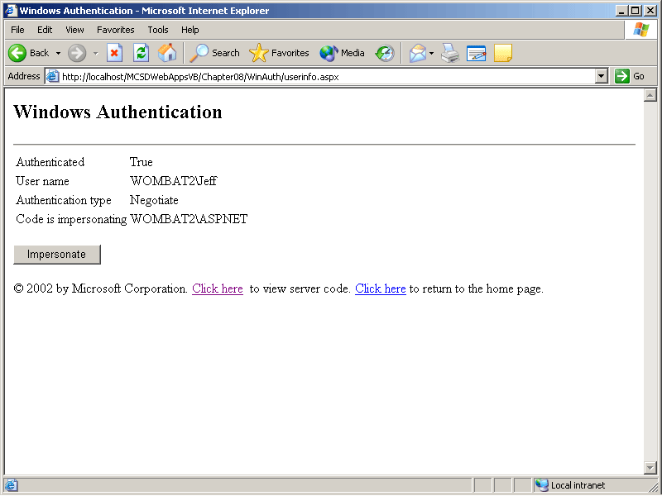
Figure 8-6. Windows authentication running locally
When you run the project remotely (as across the Internet), ASP.NET displays a dialog box in the browser to collect your user name and password, as shown in Figure 8-7.
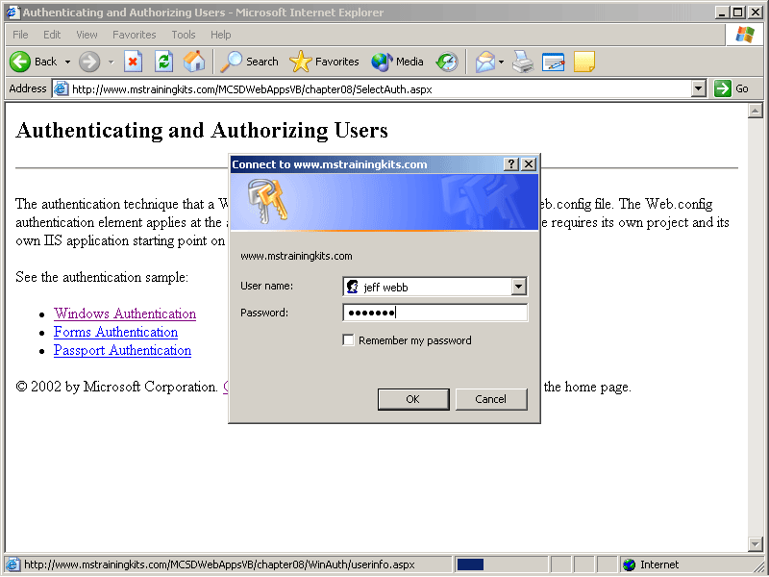
Figure 8-7. Windows authentication running remotely
If the user name and password you enter match those authorized for the network domain, ASP.NET authenticates you and authorizes you to use the application. If impersonation is enabled, the application executes using the permissions found in your user account. Otherwise, the application executes using the limited ASPNET user account.
When a user is authorized, ASP.NET issues an authorization certificate in the form of a cookie that persists for the duration of the user’s session. The user’s session ends when the browser closes or when the session times out.
Windows authentication works best in a domain-based network. Networks that use workgroups rather than domains have more limited use of network security features. Domain-based networks use a domain controller to identify and authorize network users, as shown in Figure 8-8.
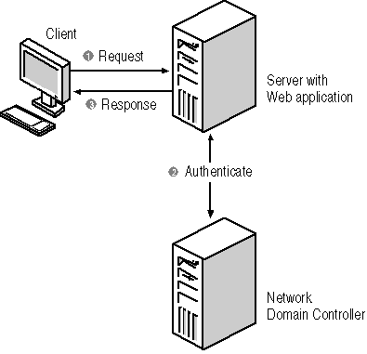
Figure 8-8. Domain-based network authentication
One of the key advantages of Windows authentication is that users who are logged on to the network don’t have to log on again to access the Web application. They are automatically authenticated. Another advantage is that corporate users can use their same network user names and passwords when accessing the Web site remotely from home or while on business trips.
Windows authentication also lets you establish another layer of security by permitting or prohibiting specific users or groups of users. Also, Windows authentication overlaps similar features found in IIS. The following sections describe these topics in more detail.
Allowing or Denying Access to Specific Users
When the application uses Windows authentication, ASP.NET checks the project’s Web.config authorization list to see which network users are allowed to access the application. The asterisk (*) and question mark (?) characters have special meaning in the authorization list: the * character indicates all users; the ? character indicates unauthenticated users. For example, the following authorization list from Web.config requires all users to be authenticated:
<authorization>
<deny users="?" /> <!-- Deny unauthenticated users -->
</authorization>
To restrict access to specific users, list their names separated by commas in an <allow> element. When ASP.NET checks the authorization list in Web.config, it accepts the first match that it finds. Be to sure to end the authorization list with a <deny> element to deny access to any nonapproved users, as shown here:
<authorization>
<allow users="contoso\DeannaMeyer, contoso\MichaelEmanuel" />
<!-- Allow two users. -->
<deny users="*" /> <!-- Deny anyone else. -->
</authorization>
This authorization list allows only two users access to the Web application. Everyone else is denied. In addition, Deanna Meyer and Michael Emanuel must have accounts on the contoso network domain.
Using Role-Based Authorization
Role-based authorization lets you identify groups of users to allow or deny based on their role in your organization. In Windows NT and Windows XP, roles map to names used to identify user groups. Windows defines several built-in groups, including Administrators, Users, and Guests. You can view, modify, or add groups using the Computer Management console, as shown in Figure 8-9.
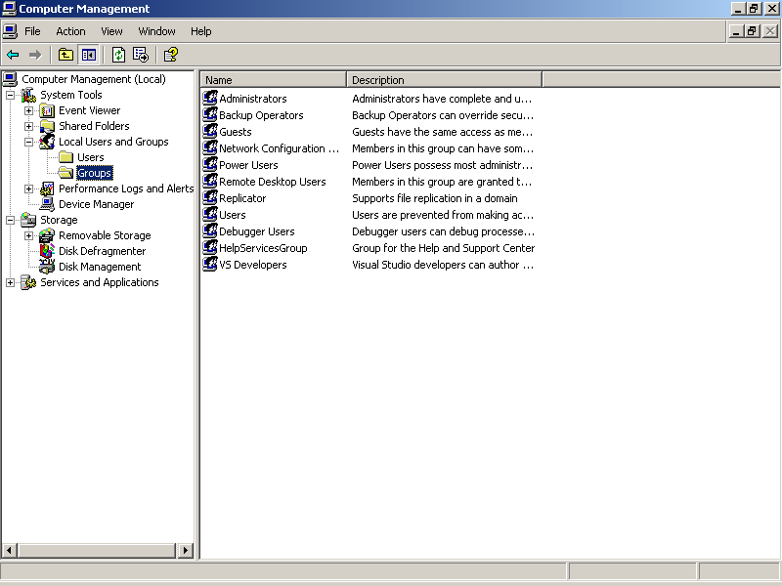
Figure 8-9. Viewing groups
To allow or deny access to certain groups of users, add the <roles> element to the authorization list in your Web application’s Web.config file. For example, the following authorization list allows access only to users logged on to the contoso domain as system administrators:
<authorization>
<allow roles="contoso\Administrators" /> <!-- Allow Administrators. -->
<deny users="*" /> <!-- Deny anyone else. -->
</authorization>
Getting the User Identity
Once a user is authenticated and authorized, your application can get information about the user by using the User object’s Identity property. The Identity property returns an object that includes the user name and role information, as shown in the following code:
Visual Basic .NET
Private Sub Page_Load(ByVal sender As System.Object, _
ByVal e As System.EventArgs) Handles MyBase.Load
spnAuthenticated.InnerText = User.Identity.IsAuthenticated
spnUserName.InnerText = User.Identity.Name
spnAuthenticationType.InnerText = User.Identity.AuthenticationType
End Sub
Visual C#
private void Page_Load(object sender, System.EventArgs e)
{
spnAuthenticated.InnerText =
User.Identity.IsAuthenticated.ToString();
spnUserName.InnerText = User.Identity.Name;
spnAuthenticationType.InnerText = User.Identity.AuthenticationType;
}
In addition, the User object provides an IsInRole method to determine the role of the current user, as in the following example:
Visual Basic .NET
If User.IsInRole("Administrators") Then
' Do something
End If
Visual C#
if(User.IsInRole("Administrators"))
// Do something.
These methods and properties can be used in conjunction with the Global module’s AuthorizeRequest event to customize the user authorization process. For example, you can use the AuthorizeRequest event to check user names against an external user file rather than use the list in Web.config.
Using IIS Settings with Windows Authentication
The authorization settings in Web.config overlap settings available in IIS. If authorization is set both in Web.config and in IIS, the IIS setting is evaluated first and then the setting in Web.config is evaluated. In general, this means that the most restrictive setting will be used.
To view authorization settings in IIS, follow these steps:
- In the IIS snap-in, right-click the Web application’s folder, and select Properties. IIS displays the folder’s Properties dialog box.
- Click the Directory Security tab, and then click Edit in the Anonymous Access And Authentication Control area. IIS displays the Authentication Methods dialog box, as shown in Figure 8-10.
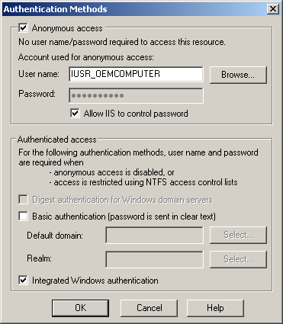
Figure 8-10. IIS authentication settings
The first group of settings in the dialog box controls anonymous access by unauthenticated users. Clearing the check box is the equivalent of specifying <deny users=“?"> in Web.config. Allowing IIS to control the password for the anonymous account is highly recommended, but this setting might need to be overridden if your application is deployed over multiple servers.
The check boxes in the second group of dialog box controls allows your application to use Basic or Digest authentication in addition to Windows authentication. Those authentication methods provide less security than Windows authentication, Forms, or Passport authentication and are implemented through IIS rather than ASP.NET.
As you can see in Figure 8-10, you can enable multiple authentication methods through IIS. If multiple methods are enabled, you can detect which method was used to authenticate a user in code by using the Identity object’s AuthenticationType method, as shown here:
Visual Basic .NET
Response.Write(User.Identity.AuthenticationType)
Visual C#
Response.Write(User.Identity.AuthenticationType);
For more information about Basic and Digest authentication, see the IIS Help.
Using Impersonation
The authentication and authorization settings in the Web.config file control access to your Web application from the outside world. However, once a user is authenticated, the application runs under the identity of the ASPNET user account by default. The ASPNET account is a limited user account created when you install the Microsoft .NET Framework.
Alternatively, you can set the application to run under the user’s account by setting the application’s identity element to enable impersonation, as shown here:
<configuration>
<system.web>
<!-- Impersonate the authenticated user in code -->
<identity impersonate="true" />
</system.web>
</configuration>
When the user requests a Web form from a folder containing the preceding Web.config settings, the Web form’s code executes in the security context of the user’s Windows account—not the default ASPNET user account. The code inherits the user’s permissions (or lack of permissions), and access to resources is granted or denied based on those permissions.
To see the impersonated identity under which code is executing, use the WindowsIdentity class’s GetCurrent method, as shown here:
Visual Basic .NET
Response.Write(System.Security.Principal.WindowsIdentity.GetCurrent().Name)
Visual C#
Response.Write(System.Security.Principal.WindowsIdentity.GetCurrent().Name);
The identity element can be used with any type of authentication; however, it is most useful with Windows authentication because Windows authentication users have accounts with specific permissions. Using the preceding Web.config settings with Forms or Passport authentication results in the ASP.NET code impersonating the generic IUSR_machinename account.
You can use the identity element to execute code using a specific Windows account. For example, the following Web.config setting causes code to run under the Administrator account:
<!-- Impersonate the Administrator account -->
<identity impersonate="true" username="Administrator" password="O#thip32x" />
You can combine this type of impersonation with folder-level authentication settings to grant authorized users administrative privileges by location. For example, the following Web.config settings allow the user Jane to execute code as the Administrator user in the /Admin folder. All other users are denied access.
<!-- From root-level Web.config file -->
<configuration>
<system.web>
<authentication mode="Windows" />
<authorization>
<deny users="?" /> <!-- Authenticate (but allow) all users. -->
</authorization>
<!-- Turn off impersonation (default). -->
<identity impersonate="false" />
</system.web>
</configuration>

<!-- From /Admin folder Web.config file -->
<configuration>
<system.web>
<authorization>
<allow users="contoso\Jane" /> <!-- Allow only Jane. -->
<deny users="*" />
</authorization>
<!-- Impersonate the Administrator account -->
<identity impersonate="true" username="Administrator"
password="O#thip32x" />
</system.web>
</configuration>
This type of folder-level impersonation can also be used effectively with Forms or Passport authentication, because you are impersonating a specific user account instead of the generic IUSR_machinename account.
Lesson 3: Using Forms Authentication
Forms authentication automatically displays a designated Web form to collect user name and password information. Code associated with that Web form authenticates and authorizes users based on a user list stored in the application’s Web.config file or in a separate user database.
The advantage of Forms authentication is that users do not have to be member of a domain-based network to have access to your application. Another advantage is that many Web applications—particularly commercial sites where customers order products—want to have access to user information. Forms authentication makes these types of applications easier to create.
After this lesson, you will be able to
- Activate Forms authentication for your Web application
- Create a Web form to collect user name and password information
- Authenticate users based on a user list stored in the application’s Web.config file
- Add new users and authenticate existing ones from a database
- Limit access to specific locations
Estimated lesson time: 20 minutes
Enabling Forms Authentication
Forms authentication allows you to create your own database of users and validate the identity of those users when they visit your Web site.
To use Forms authentication to identify and authorize users, follow these steps:
- Set the authentication mode in Web.config to Forms.
- Create a Web form to collect logon information.
- Create a file or database to store user names and passwords.
- Write code to add new users to the user file or database.
- Write code to authenticate users against the user file or database.
When someone accesses a Web application that uses Forms authentication, ASP.NET displays the logon Web form specified in Web.config. Once a user is authorized, ASP.NET issues an authorization certificate in the form of a cookie that persists for an amount of time specified by the authentication settings in Web.config. Figure 8-11 illustrates the authentication process.
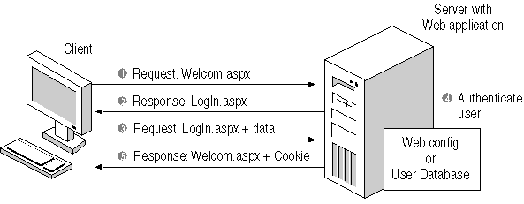
Figure 8-11. Forms authentication
The difference between Windows authentication and Forms authentication is that in Forms authentication your application performs all the authentication and authorization tasks. You must create Web forms and write code to collect user names and passwords and to check those items against a list of authorized users.
The following sections describe how to implement Forms authentication in your application based on the general steps listed earlier in this section.
Setting the Forms Authentication Mode
You set an application’s authentication mode in the Web.config file’s <authorization> element. To set your application to use Forms authentication, make the following changes to the Web.config file:
<authentication mode="Forms" > <!-- Set authentication mode -->
<forms loginUrl="LogIn.aspx" > <!-- Specify a log on form -->
<credentials passwordFormat="Clear"> <!-- Create a user list -->
<user name="Jesse" password="JuneBug"/>
<user name="Linda" password="Liste"/>
<user name="Henry" password="Henry"/>
</credentials>
</forms>
</authentication>

<authorization>
<deny users="?" /> <!—Deny all unauthenticated users -->
</authorization>
The preceding Web.config fragment shows a simplified example of Forms authentication using most of the default settings and including a user list as part of the Web.config file. Table 8-2 lists all the possible attributes for the elements that make up the Forms authentication settings.
Table 8-2. Forms Authentication Settings in Web.config
Element | Attribute | Description
<authentication> | mode | Set to Forms to enable Forms authentication.
<forms> | name | Use to set the name of the cookie in which to store the user’s credential. The default is .authaspx. If more than one application on the server is using Forms authentication, you need to specify a unique cookie name for each application.
 | loginUrl | Use to set the name of the Web form to display if the user has not already been authenticated. If omitted, the default is Default.aspx.
 | protection | Use to set how ASP.NET protects the authentication cookie stored on the user’s machine. The default is All, which performs encryption and data validation. Other possible settings are Encryption, Validation, and None.
 | timeout | Use to set the number of minutes the authentication cookie persists on the user’s machine. The default is 30, indicating 30 minutes. ASP.NET renews the cookie automatically if it receives a request from the user and more than half of the allotted time has expired.
 | path | Use to set the path used to store the cookie on the user’s machine. The default is a backslash (\).
<credentials> | passwordFormat | Use to set the algorithm used to encrypt the user’s password. The default is SHA1. Other possible settings are MD5 and Clear (which prevents encryption).
<users> | name | Use to set the name of the user.
 | password | Use to set the password for the user.
The <credentials> element allows you to store your user list in the Web.config file. That is convenient for simple authentication, where an administrator adds new users and sets their passwords, but it’s not the best approach if you allow users to set up their own accounts or maintain their own passwords.
In those cases, you will want to create a users file or a users database to store user names and encrypted passwords. Using a database has the added benefit of allowing you to store all sorts of additional information about the user, such as shipping address and order history.
The following section shows how to authenticate users using credentials stored in Web.config. The subsequent sections show the more advanced (and more complicated) approach of using a user database.
Creating a LogIn Web Form
To authenticate users through Forms authentication, you need to create a Web form that allows users to log on. This Web form is identified by name in the <forms> element of Web.config.
The login Web form can be as simple as a pair of text boxes and a Button control, or it can appear on a page containing other, nonsecure content. For example, you can include logon fields on an application home page, as shown in Figure 8-12.
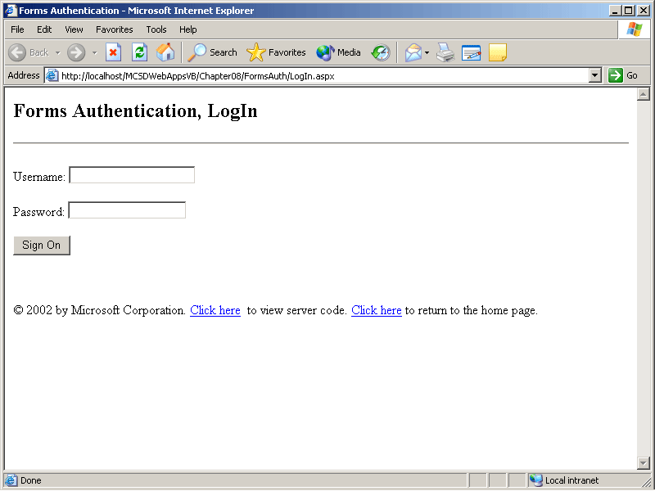
Figure 8-12. Login fields on an application home page
When the user clicks Sign On, the application authenticates the user name and password, issues an authentication certificate, and allows access to the rest of the application, as shown in the following code:
Visual Basic .NET
' Add at module-level.
Imports System.Web.Security

Private Sub butSignOn_Click(ByVal sender As System.Object, _
ByVal e As System.EventArgs) Handles butSignOn.Click
' Authenticate username/password from <credentials>.
If FormsAuthentication.Authenticate(txtUserName.Text, txtPassword.Text) _
Then
' If found, display the application's Start page.
FormsAuthentication.RedirectFromLoginPage(txtUserName.Text, True)
Else
' Otherwise, clear the password.
txtPassword.Text = ""
' If third try, display "Access Denied" page.
If CInt(ViewState("Tries")) > 1 Then
Response.Redirect("Denied.htm")
Else
' Otherwise, increment number of tries.
ViewState("Tries") = CInt(ViewState("Tries")) + 1
End If
End If
End Sub
Visual C#
// Add at module-level.
using System.Web.Security;

private void butSignOn_Click(object sender, System.EventArgs e)
{
// Authenticate username/password from <credentials>.
if (FormsAuthentication.Authenticate(txtUserName.Text,
txtPassword.Text))
// If found, display the application's Start page.
FormsAuthentication.RedirectFromLoginPage(txtUserName.Text, true);
else
{
// Otherwise, clear the password.
txtPassword.Text = "";
// If third try, display "Access Denied" page.
if (System.Convert.ToInt32(ViewState["Tries"]) > 1)
Response.Redirect("Denied.htm");
else
// Otherwise, increment number of tries.
ViewState["Tries"] = System.Convert.ToInt32(ViewState["Tries"])
+ 1;
}
}
There are a few important things to note about the preceding code:
- The FormsAuthentication class is part of the System.Web.Security namespace, so you must include that namespace using the Visual Basic .NET Imports statement or the Visual C# using statement, or the fully qualified references to the class.
- The FormsAuthentication class’s Authenticate method checks the user name and password against the user list found in the <credentials> element of Web.config.
- The FormsAuthentication class’s RedirectFromLoginPage method displays the application’s start page. If the logon fields appear on the application’s start page, you should disable them or otherwise indicate a successful logon.
- If the user name and password aren’t valid, the code lets the user have two more tries before displaying an Access Denied page. That page is an HTML page rather than a Web form, since access to any Web forms in the application is also denied. If you redirect users to another page in this way, make sure that the page is outside the scope of the application.
Use the FormsAuthentication class to sign out when the user has finished with the application or when you want to remove the authentication cookie from his or her machine. For example, the following code ends the user’s access to an application and requires him or her to sign back in to regain access:
Visual Basic .NET
Imports System.Web.Security

Private Sub butSignOut_Click(ByVal sender As System.Object, _
ByVal e As System.EventArgs) Handles butSignOut.Click
' Remove authentication cookie.
FormsAuthentication.SignOut()
' Redirect back to this page (displays log in screen).
Response.Redirect("UserInfo.aspx")
End Sub
Visual C#
using System.Web.Security;

private void butSignOut_Click(object sender, System.EventArgs e)
{
// Remove authentication cookie.
FormsAuthentication.SignOut();
// Redirect back to this page (displays log in screen).
Response.Redirect("UserInfo.aspx");
}
Authenticating Users with a Database
The preceding sections showed how to authenticate users based on a list in Web.config. The FormsAuthentication class’s Authenticate method is set up to read from that file automatically. That’s fine if user names and passwords are created and maintained by a system administrator, but if you allow users to create their own user names or change their passwords, you’ll need to store that information outside the Web.config file. This is because changing Web.config at run time causes the Web application to restart, which resets any Application state and Session state variables used by the application.
You can store user names and passwords in any type of file; however, using a database has the following significant advantages:
- User names can be used as primary keys to store other information about the user.
- Databases can provide high performance for accessing user names and passwords.
- Adding, modifying, and accessing records are standardized through SQL.
When storing user names and passwords in a file or database, you have the option of encrypting them using the FormsAuthentication class’s HashPasswordForStoringInConfigFile method. This uses the SHA1 or MD5 algorithms to encrypt data, as shown here:
Visual Basic .NET
' Encrypt the password.
Password = FormsAuthentication.HashPasswordForStoringInConfigFile(Password, _
"SHA1")
Visual C#
Password = FormsAuthentication.HashPasswordForStoringInConfigFile(Password,
"SHA1");
The following sections show how to add new user names and passwords to a simple database and how to use that database to authenticate users.
Adding Users to a Database
To add users to a database, collect the user name and password from two TextBox controls and provide an event procedure to add the user that displays a message indicating whether the user was added. The following event procedure calls the helper function AddUser to add the user name and password to the database:
Visual Basic .NET
Private Sub butNewUser_Click(ByVal sender As System.Object, _
ByVal e As System.EventArgs) Handles butNewUser.Click
If AddUser(txtUserName.Text, txtPassword.Text) Then
spnNote.InnerText = "User added."
Else
spnNote.InnerText = "User exists. Choose a different user name."
End If
End Sub
Visual C#
private void butNewUser_Click(object sender, System.EventArgs e)
{
if (AddUser(txtUserName.Text, txtPassword.Text))
spnNote.InnerText = "User added.";
else
spnNote.InnerText = "User exists. Choose a different user name.";
}
The AddUser helper function shown in the following code encrypts the password before storing the user name and password in a database using the SQL INSERT command. If the user name already exists in the database, the exception-handling block catches the error and returns False to indicate that the user was not added.
Visual Basic .NET
Private Function AddUser(ByVal UserName As String, ByVal Password_
As String)
As Boolean
' Declare variable to track success/failure.
Dim bSuccess As Boolean
' Encrypt the password.
Password = _
FormsAuthentication.HashPasswordForStoringInConfigFile(Password, _
"SHA1")
' Create command to insert user name and password.
Dim oleCommand As New OleDbCommand("INSERT INTO Users" + _
" VALUES('" + UserName + "', '" + Password + "')", oledbUsers)
' Catch errors in case record already exists.
Try
' Open the database connection.
oledbUsers.Open()
' If record added, set success to true.
If oleCommand.ExecuteNonQuery() Then bSuccess = True
' Close connection.
oledbUsers.Close()
Catch
' Otherwise, success if false.
bSuccess = False
' Close connection.
oledbUsers.Close()
End Try
' Return success/failure.
Return bSuccess
End Function
Visual C#
private bool AddUser(string UserName, string Password)
{
// Declare variable to track success/failure.
bool bSuccess = false;
// Encrypt the password.
Password = FormsAuthentication.HashPasswordForStoringInConfigFile
(Password, "SHA1");
// Create command to insert user name and password.
OleDbCommand oleCommand = new OleDbCommand("INSERT INTO Users" +
" VALUES('" + UserName + "', '" + Password + "')", oledbUsers);
// Catch errors in case record already exists.
try
{
// Open the database connection.
oledbUsers.Open();
// If record added, set success to true.
if (oleCommand.ExecuteNonQuery() != 0)
{
bSuccess = true;
// Close connection.
oledbUsers.Close();
}
}
catch
{
// Otherwise, success if false.
bSuccess = false;
// Close connection.
oledbUsers.Close();
}
// Return success/failure.
return bSuccess;
}
Authenticating Users from a Database
When you authenticate users from Web.config, you use the Authenticate method. When you authenticate users from a database, you must write your own code to find and compare user names and passwords. The following event procedure uses the CheckPassword helper function to validate the user name and password text boxes before authenticating the user and allowing access to the application:
Visual Basic .NET
Private Sub butSignOn_Click(ByVal sender As System.Object, _
ByVal e As System.EventArgs) Handles butSignOn.Click
' If user name and password are found,
' authorize the user and show start page.
If CheckPassword(txtUserName.Text, txtPassword.Text) Then
FormsAuthentication.RedirectFromLoginPage(txtUserName.Text, True)
Else
' Display message.
spnNote.InnerText = "User name or password not found. Try again."
' Allow three tries to log in.
ViewState("tries") = ViewState("tries") + 1
If ViewState("tries") > 3 Then
Response.Redirect("Denied.htm")
End If
End If
End Sub
Visual C#
private void butSignOn_Click(object sender, System.EventArgs e)
{
// Authenticate username/password from <credentials>.
if (CheckPassword(txtUserName.Text, txtPassword.Text))
// If found, display the application's Start page.
FormsAuthentication.RedirectFromLoginPage(txtUserName.Text, true);
else
{
// Otherwise, clear the password.
txtPassword.Text = "";
// Display message.
spnNote.InnerText = "User name or password not found. Try again.";
// If third try, display "Access Denied" page.
if (System.Convert.ToInt32(ViewState["Tries"]) > 1)
Response.Redirect("Denied.htm");
else
{
// Otherwise, increment number of tries.
ViewState["Tries"] =
System.Convert.ToInt32(ViewState["Tries"]) + 1;
if (System.Convert.ToInt32(ViewState["Tries"]) > 3)
Response.Redirect("Denied.htm");
}
}
}
The CheckPassword helper function shown in the following code encrypts the password, finds the database record based on the user name, and compares the encrypted password against the password found in the database. Access to the database is performed within an exception-handling block to prevent locking conflicts from displaying errors to the user.
Visual Basic .NET
Private Function CheckPassword(ByVal UserName As String, _
ByVal Password As String) As Boolean
' Declare variable to track success/failure.
Dim bSuccess As Boolean
' Encrypt the password.
Password = _
FormsAuthentication.HashPasswordForStoringInConfigFile(Password, _
"SHA1")
' Create command to get row from users table based on UserName.
Dim oleCommand As New OleDbCommand("SELECT * FROM Users" + _
" WHERE UserName='" + txtUserName.Text + "'", oledbUsers)
' Check for errors using database
Try
' Open the database connection.
oledbUsers.Open()
' Get the author ID.
Dim rdrUsers As OleDbDataReader = oleCommand.ExecuteReader()
While rdrUsers.Read()
If Password = rdrUsers.Item("Password") Then bSuccess = True
End While
' Close connection.
oledbUsers.Close()
Catch
' Otherwise set failure.
bSuccess = False
' Close connection.
oledbUsers.Close()
End Try
Return bSuccess
End Function
Visual C#
private bool CheckPassword(string UserName, string Password)
{
// Declare variable to track success/failure.
bool bSuccess = false;
// Encrypt the password.
Password =
FormsAuthentication.HashPasswordForStoringInConfigFile(Password,
"SHA1");
// Create command to get row from users table based on UserName.
OleDbCommand oleCommand = new OleDbCommand("SELECT * FROM Users" +
" WHERE UserName='" + txtUserName.Text + "'", oledbUsers);
// Check for errors using database
try
{
// Open the database connection.
oledbUsers.Open();
// Get the author ID.
OleDbDataReader rdrUsers = oleCommand.ExecuteReader();
while (rdrUsers.Read())
{
if (Password == rdrUsers["Password"].ToString())
bSuccess = true;
}
// Close connection.
oledbUsers.Close();
}
catch
{
// Otherwise set failure.
bSuccess = false;
// Close connection.
oledbUsers.Close();
}
return bSuccess;
}
Controlling Access to Specific Locations
The authorization settings in the Web.config file apply hierarchically within the folder structure of a Web application. For instance, you might want to allow all users access to the root folder of a Web application but restrict access to Web forms (and tasks) available from a subfolder. To do this, set the authentication type in the root folder’s Web.config file, and then use the <authorization> element in the subfolder’s Web.config file to restrict access.
In the following Web.config settings, the root folder settings allow all users access and the /Restricted folder’s Web.config file allows access only to Henry:
<!-- From Web.config in application's root folder -->
<configuration>
<system.web>
<authentication mode="Forms" > <!-- Set authentication mode -->
<forms loginUrl="LogIn.aspx" > <!-- Specify a log on form -->
<credentials passwordFormat="Clear"><!-- Create a user list -->
<user name="Jesse" password="JuneBug"/>
<user name="Linda" password="Leste"/>
<user name="Henry" password="Henry" />
</credentials>
</forms>
</authentication>
<authorization>
<allow users="*" /> <!-- Allow all users -->
</authorization>
</system.web>
</configuration>

<!-- From Web.config in /Restricted folder -->
<configuration>
<system.web>
<authorization>
<allow users="Henry" /> <!-- Allow Henry -->
<deny users="*" /> <!-- Deny everyone else -->
</authorization>
</system.web>
</configuration>
When you run a Web application with the preceding Web.config settings, users are not authenticated until they request a resource from the /Restricted folder. When a user requests a Web form from the /Restricted folder, the LogIn.aspx Web form is displayed and the user is authenticated.
NOTE
Authentication type (Windows, Forms, or Passport) can be set only at the application’s root folder. To change authentication type in a subfolder, you must create a new Web application project and application starting point for that subfolder.
Lesson 4: Using Passport Authentication
Passport authentication identifies users via Microsoft Passport’s single sign-on service. Microsoft Passport is meant to provide Internet users with a single identity that they can use to visit a wide variety of Web sites that require authentication. Information about the user is available to your application through a profile that is stored with Microsoft.
The advantages of Passport authentication are that the user doesn’t have to remember separate user names and passwords for various Web sites and that the user can maintain his or her profile information in a single location. Passport authentication also provides access to other Microsoft services, such as Passport Express Purchase.
After this lesson, you will be able to
- Install the Passport SDK
- Activate Passport authentication for your application
- Get information from the user’s Passport profile
- Sign out the user from your Web application by deleting the Passport cookies
Estimated lesson time: 20 minutes
Enabling Passport Authentication
Passport authentication uses the Microsoft centralized authentication provider to identify users. Passport provides a way to for users to use a single identity across multiple Web applications. To use Passport authentication in your Web application, you must install the Passport SDK, which is available by searching the Downloads area of the Microsoft Developer Network (MSDN), at http://msdn.microsoft.com/downloads.
The Passport SDK is free for preproduction development and testing. To deploy a site for public use, you must obtain an annual license from Microsoft. You can obtain more information about licensing from http://www.microsoft.com/netservices/passport/.
When a user accesses an application that implements Passport authentication, ASP.NET checks the user’s machine for a current passport authentication cookie. If none is found, ASP.NET directs the user to a Passport sign-on page. Once the user signs in, the Passport service authenticates the user, stores an authentication cookie on the user’s computer, and directs the user back to the originally requested Web page. Figure 8-13 illustrates the Passport authentication process.
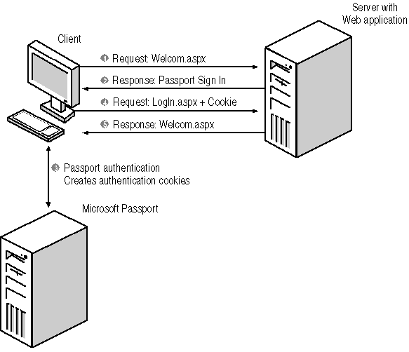
Figure 8-13. The Passport authentication process
To use Passport authentication, follow these steps:
- Install the Passport SDK. Passport is not included with Visual Studio, although the .NET Framework does include classes for working with the Passport SDK once it is installed.
- Set the application’s authentication mode to Passport in Web.config. Set authorization to deny unauthenticated users.
- Use the PassportAuthentication_OnAuthenticate event to access the user’s Passport profile to identify and authorize the user.
- Implement a sign-out procedure to remove Passport cookies from the user’s machine.
For example, the following Web.config settings enable Passport authentication and require all users to be authenticated:
<authentication mode="Passport" />

<authorization>
<deny users="?" /> <!-- Deny unauthenticated users -->
</authorization>
When you run an application locally with these settings, you are automatically redirected to the Passport sign-on page. If you’ve installed the preproduction (unlicensed) version of the Passport SDK, the sign-on page is not the same as the page displayed for a deployed site. Figure 8-14 shows the two Passport sign-on pages.
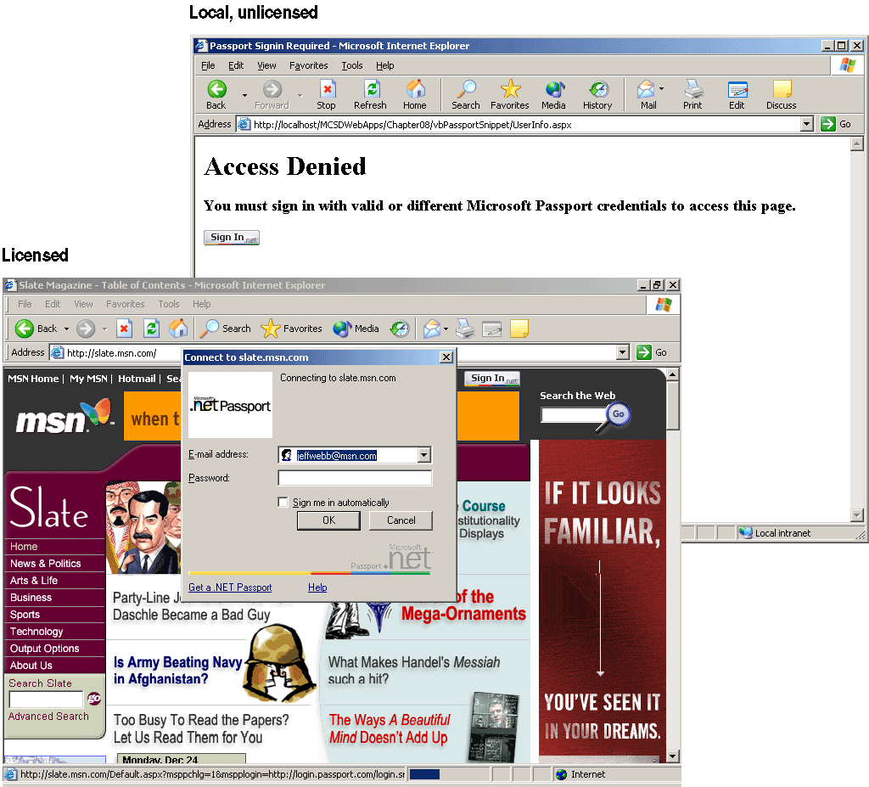
Figure 8-14. Passport sign-on pages
Once the user has signed in, Passport stores an authorization cookie on the user’s machine and redirects the user back to his or her originally requested page. Passport stores a profile of information about the user. You can access that profile from the PassportAuthentication_OnAuthenticate event in the Global.asax module, as shown here:
Visual Basic .NET
' Add at module-level.
Imports System.Web.Security

Private Sub PassportAuthentication_OnAuthenticate(ByVal sender As Object, _
ByVal e As PassportAuthenticationEventArgs)
' Get Session's passport identity if authenticated.
If e.Identity.IsAuthenticated Then
Response.Write("Name: " & e.Identity.Item("FirstName") & _
" " & e.Identity.Item("LastName") & "<br>")
Response.Write("Address: " & e.Identity.Item("City") & _
" " & e.Identity.Item("PostalCode") & "<br>")
Response.Write("Email: " & e.Identity.Item("PreferredEmail") & _
"<br>")
Response.Write("Passport ID: " & e.Identity.Name & "<br>")
End If
End Sub
Visual C#
// Add at module-level.
using System.Web.Security;

protected void PassportAuthentication_OnAuthenticate(Object sender,
PassportAuthenticationEventArgs e)
{
// Get Session's passport identity if authenticated.
if (e.Identity.IsAuthenticated)
{
Response.Write("Name: " + e.Identity["FirstName"] +
" " + e.Identity["LastName"] + "<br>");
Response.Write("Address: " + e.Identity["City"] +
" " + e.Identity["PostalCode"] + "<br>");
Response.Write("Email: " + e.Identity["PreferredEmail"] +
"<br>");
Response.Write("Passport ID: " + e.Identity.Name + "<br>");
}
}
The preceding code displays the user’s name, location, and identity information from his or her Passport profile. If you’ve installed the preproduction Passport SDK, that information reflects a test account rather than live data, as shown in Figure 8-15.
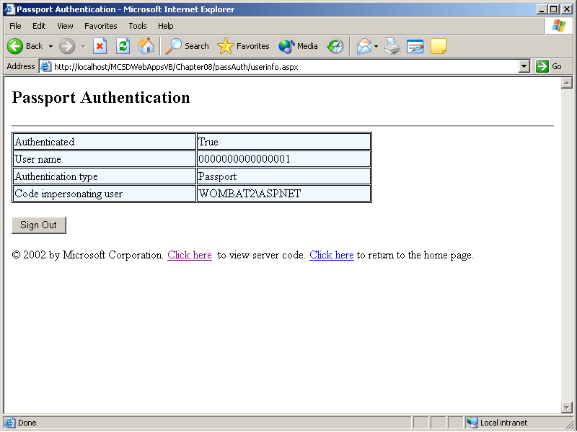
Figure 8-15. Passport identity information for the test account
The Passport authorization and profile information are stored in five separate cookies on the user’s machine. The Passport SDK requires that you remove these cookies when the user signs out of your Web application. The following event procedure demonstrates how to sign out by deleting the Passport cookies:
Visual Basic .NET
Private Sub butSignOut_Click(ByVal sender As System.Object, _
ByVal e As System.EventArgs) Handles butSignOut.Click
' Sign out by deleting Passport cookies.
Response.Cookies("MSPProf").Expires = Now
Response.Cookies("MSPAuth").Expires = Now
Response.Cookies("MSPSecAuth").Expires = Now
Response.Cookies("MSPProfC").Expires = Now
Response.Cookies("MSPConsent").Expires = Now
' Redisplay this page (goes back to sign-on).
Response.Redirect("UserInfo.aspx")
End Sub
Visual C#
private void butSignOut_Click(object sender, System.EventArgs e)
{
// Sign out by deleting Passport cookies.
Response.Cookies["MSPProf"].Expires = DateTime.Now;
Response.Cookies["MSPAuth"].Expires = DateTime.Now;
Response.Cookies["MSPSecAuth"].Expires = DateTime.Now;
Response.Cookies["MSPProfC"].Expires = DateTime.Now;
Response.Cookies["MSPConsent"].Expires = DateTime.Now;
// Redisplay this page (goes back to sign-on).
Response.Redirect("UserInfo.aspx");
}
Passport authentication also provides additional commercial and child-protection features that are explained in the Passport SDK.
Lesson 5: Providing Secure Communication
Up to now, we’ve discussed security as a matter of identifying users and preventing unauthorized users from accessing your Web applications, but it’s just as important to ensure that sensitive data sent across the Internet can’t be read by others.
To provide secure communication across the Internet, IIS supports a standardized means of encrypting and decrypting Web requests and responses. This cryptography requires that you request an encryption key called a server certificate from an independent third party called a certificate authority.
After this lesson, you will be able to
- Understand the process of using the Secure Sockets Layer (SSL) in IIS
- Get a server certificate to enable secure, encrypted communication between your Web application and users
- Begin secure communication between a user and your Web application
- End secure communication
- Require secure communication before users can access a Web form
Estimated lesson time: 20 minutes
Enabling Secure Communication
The Secure Sockets Layer (SSL) is the standard means of ensuring that data sent over the Internet can’t be read by others. When a user requests a secure Web page, the server generates an encryption key for the user’s session and then encrypts the page’s data before sending a response. On the client side, the browser uses that same encryption key to decrypt the requested Web page and to encrypt new requests sent from that page. Figure 8-16 illustrates the process.
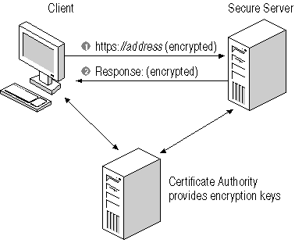
Figure 8-16. Secure communication using SSL
Using SSL in your application requires special authorization from a recognized certificate authority. This authorization comes in the form of a server certificate, which you install in IIS to identify your server. The certificate authority licenses server certificates (for a fee) and acts as a clearinghouse to verify your server’s identity over the Internet.
When a user’s browser begins secure communications, it requests the server certificate and checks it against a list of trusted sites provided by the certificate authority. If the server certificate does not match one of the sites already authorized by the user, or if the server certificate does not match the Web address for which it was registered, or if there are any other problems with the server certificate, the browser displays a warning, as shown in Figure 8-17.
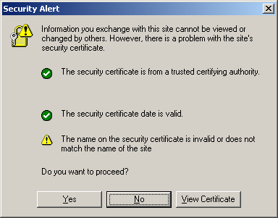
Figure 8-17. Problems with the server certificate
In this way, the certificate authority not only provides encryption for secure data transmission, but it also provides assurance to users that your Web site is authentic. The largest certificate authority is VeriSign. At the time of this writing, in addition to their fee-based services, they also offer free trial certificates for testing and evaluation at http://www.verisign.com.
To use SSL in your Web application, follow these steps:
- Generate a certificate request from IIS.
- Request a certificate from a certificate authority.
- Install the certificate on the server using IIS.
- Install the certificate on browsers if you are using a test certificate.
- Use the Secure Hypertext Transfer Protocol (HTTPS) when accessing secure pages in your application.
The following sections describe these steps in greater detail.
Generating a Certificate Request
Before you can request a server certificate from a certificate authority, you must generate a certificate request from IIS. The certificate request contains encrypted information about your server that the certificate authority uses to identify your server over the Internet.
To generate a certificate request from the IIS snap-in:
- Select Default Web Site in the console tree of the IIS snap-in, and then choose Properties from the Action menu. IIS displays the Default Web Site Properties dialog box.
- Click the Directory Security tab in the Properties dialog box, and then click Server Certificate. IIS starts the Web Server Certificate Wizard, as shown in Figure 8-18.
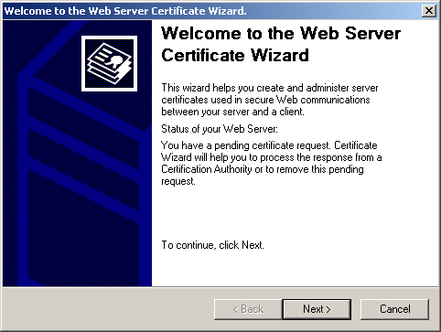
Figure 8-18. The Web Server Certificate Wizard
- Step through the wizard by reading each screen and clicking Next. The wizard instructions are straightforward.
- When you click Finish at the end, the wizard creates an encrypted text file with the .cer file extension. That file is the certificate request that you send to the certificate authority.
IIS requires that a certificate be created at the server root before secure communications can be created or configured for subordinate sites on the server. That’s why you have to select Default Web Site (or the root Web site if you have renamed it) in step 1. After you have installed a server certificate at the root, you can repeat the process for subordinate sites if you want separate certificates for those sites.
Requesting a Certificate
The process of requesting a server certificate from a certificate authority varies depending on the certificate authority you select. As mentioned earlier, VeriSign provides test certificates at no cost, which suits the purposes of this book very well!
To request a server certificate, follow these steps:
- Visit the certificate authority’s Web site, and request a server certificate for SSL. The various levels of security and support are typically based on an annual fee.
- Select the type of server certificate you want to request, and complete the registration information for the request.
- Copy or e-mail the certificate request you created in the preceding section to the certificate authority.
Once approved, the certificate authority will send you the server certificate, usually as part of an e-mail message. Save the certificate as a text file with the .cer file extension by cutting and pasting it into Notepad or some other editor, as shown in Figure 8-19.
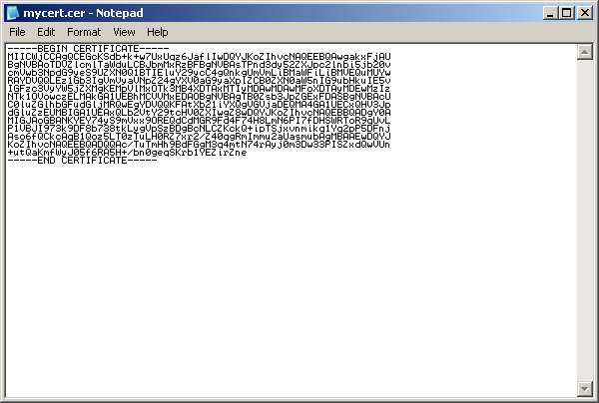
Figure 8-19. Saving the server certificate
Installing the Certificate
After you have saved your server certificate, you can install it in IIS to enable SSL for your Web applications.
To install a server certificate in IIS:
- Select Default Web Site in the console tree of the IIS snap-in, and then choose Properties from the Action menu. IIS displays the Default Web Site Properties dialog box.
- Click the Directory Security tab in the Properties dialog box, and then click Server Certificate. IIS starts the Web Server Certificate Wizard.
- Click Next, and select Process The Pending Request And Install The Certificate, as shown in Figure 8-20.
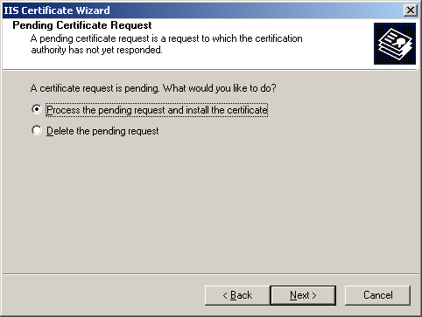
Figure 8-20. Installing the certificate with the IIS Web Server Certificate Wizard
- Click Next, and enter the name of the certificate file, as shown in Figure 8-21. The certificate file is the file you created in the preceding section.
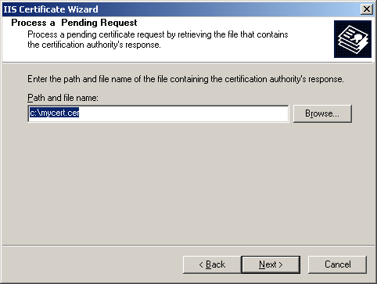
Figure 8-21. Entering the name of the server certificate file
- Click Next, and then click Finish to complete the installation.
Using Secure Communications
After you have installed the server certificate, secure communication is enabled for any Web pages requested through HTTPS. For example, the following hyperlink displays a secure Web page, as shown in Figure 8-22.
<a href="https://www.contoso.com/mscdkit/Secure.aspx">Go to secure page.</a>
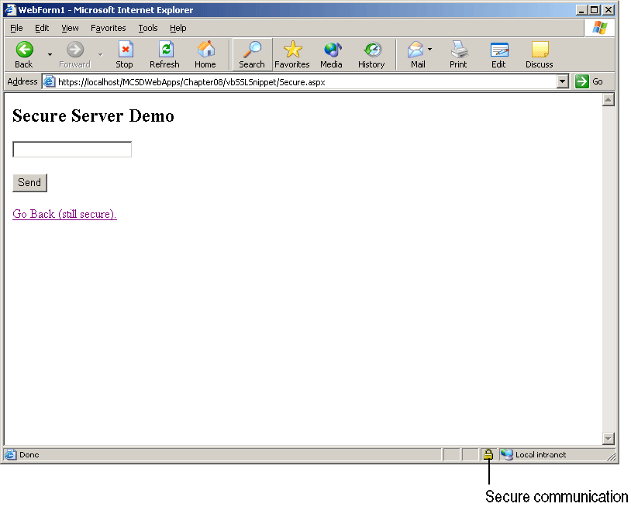
Figure 8-22. Secure Web page
The protocol HTTPS is what initializes the secure communication. When you’ve begun secure communication, it continues until you specify a nonsecure site. For example, clicking the Go Back link on the page shown in Figure 8-22 continues the secure communication because the link uses a relative address, as shown here:
<a href="Default.aspx">Go Back (still secure).</a>
To end secure communication, you need to include http in the URL, as in the following link:
<a href="http://www.contoso.com/mscdkit/Default.aspx">
Go Back (not secure).</a>
IIS lets you require secure communication for specific folders or files in your Web application. This prevents users from accidentally (or intentionally) viewing a secure page using nonsecure HTTP.
To require secure communication for a Web page using IIS, follow these steps:
- Select the folder or file that requires secure communication, and then choose Properties from the Action menu. IIS displays the Properties dialog box.
- Click the Directory Security tab, and then click Edit in the Secure Communications group. IIS displays the Secure Communications dialog box, as shown in Figure 8-23.
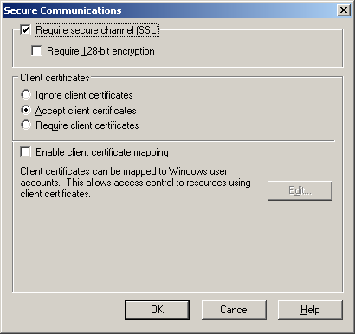
Figure 8-23. The Secure Communications dialog box
- Select the Require Secure Channel (SSL) check box, and click OK.
When you require secure communication for a Web page, that page can’t be viewed using HTTP. The user must type in or click a link using https; otherwise, access is denied, as shown in Figure 8-24.
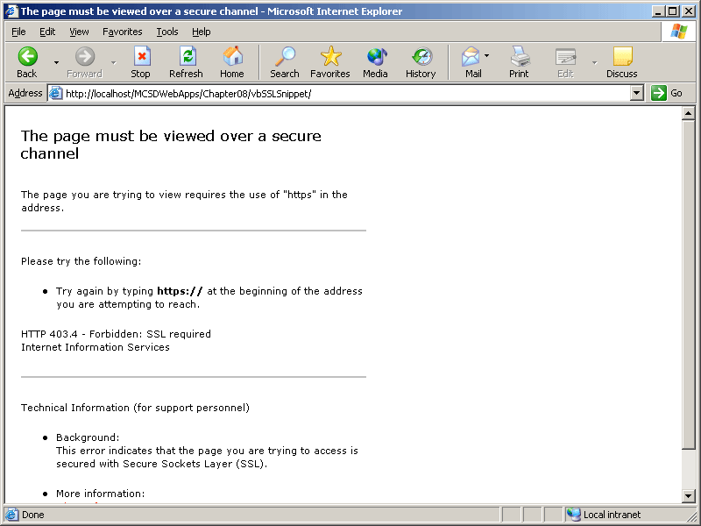
Figure 8-24. Access denied
Because the difference between using http and https is a somewhat obscure distinction for most users to remember, it’s important to provide an http entry point for your application that links to the secure (HTTPS) pages. The http entry point can be simply a default page within the Web site that immediately redirects the user to the secure site. Requiring secure communication for an entire Web site is a sure way to cut traffic down to zero!
Summary
- Authentication is the process of identifying users. Authorization is the process of granting access to those users.
- The default method of access to a Web application is anonymous access. Anonymous users are granted access through the Windows IUSER_machinename user account, and the Web application’s code runs using the ASPNET user account.
- Use the <identity> element in the Web.config file to run code using the permissions of a specific user.
- ASP.NET provides three authentication modes through the System.Web.Security namespace: Windows, Forms, and Passport.
- HTML pages aren’t automatically included under ASP.NET authentication. To ensure that users are authenticated before they can view those types of files, use IIS to map the .htm and .html file extensions to the ASP.NET executable.
- To require authentication, add a <deny users=“?”> element in the authorization section of Web.config. This applies to all three authentication types.
- Use the <authorization> element to allow or deny access to users under Windows authentication.
- To restrict access to a subfolder, add a Web.config file containing an <authorization> element specifying the users allowed to access the folder.
- Use the <credentials> element or an external user database to allow users under Forms authentication.
- Changing the Web.config file restarts the Web application, so it’s not a good idea to add users to the Web.config <credentials> element at run time. Instead, use an external file or database to store user names and passwords.
- Install the Passport SDK to enable the Passport classes in the System.Web.Security namespace.
- To enable secure, encrypted communication over the Internet, install a server certificate and use HTTPS.
Lab: Creating a Secure Application
In this lab, you’ll create a simple application that uses Forms authentication to identify and authorize users. The application allows new users to add their user name and password, allows existing users to sign in, and displays the user’s identity once he or she has signed in. When complete, the Web application will appear as shown in Figure 8-25.
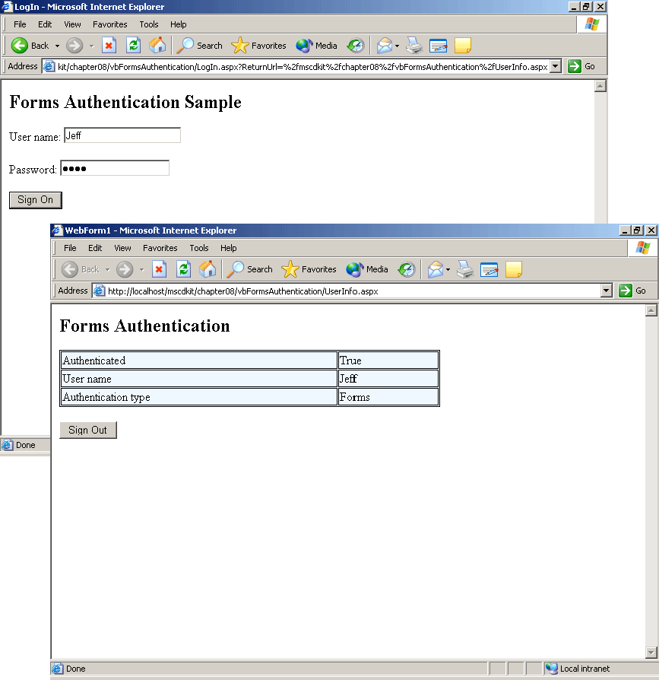
Figure 8-25. The LogIn and UserInfo Web forms
Estimated lesson time: 30 minutes
Exercise 1: Enable Forms Authentication

To enable Forms authentication:

- Create a new ASP.NET Web Forms application, and open the Web.config file generated for the project.
- Make the changes to the <authentication> element shown here:
- <authentication mode="Forms">
- <forms loginUrl="LogIn.aspx">
- <credentials passwordFormat="SHA1">
- </credentials>
- </forms>
</authentication>
- The preceding authentication settings enable Forms authentication, direct unauthenticated users to the LogIn.aspx Web form, and enable password encryption using the SHA1 algorithm. To require authentication using these settings, add the following <authorization> element to the Web.config file:
- <authorization>
- <deny users="?" /> <!-- Deny unauthorized users -->
</authorization>
This authorization setting denies access to any unauthenticated users, thus forcing authentication.
When the changes to Web.config have been made, you can create the LogIn.aspx Web form that allows users to add new accounts and to log on to existing ones.
Exercise 2: Create the LogIn Web Form
In this exercise, you’ll create a Web form named LogIn.aspx and a data file named Users.xml that are used to authenticate users. Because this is a simplified example, LogIn.aspx allows users to create a new account if their user name was not found.
In the real world, you might want to direct users to a separate Web form for creating new accounts or you might want an administrator to create their accounts and e-mail their passwords back to them. In either case, the basic concepts are the same.
To create the LogIn Web form and user data file:
- Use Visual Studio or another text editor to create a text file containing the following line:
<users name="" password="" />
The sample will use this file to as a template to store user names and passwords. Because passwords will be encrypted, the first name and passwords are blank—you can delete this line later, after other user names and passwords have been added.
- Create the LogIn.aspx Web form. This Web form contains text boxes, validation, and other controls, as shown in the following table.
Control type | Property | Value
Label | Text | User name:
TextBox | ID | txtUserName
RequiredFieldValidator | ID | vldUserName
 | ControlToValidate | txtUserName
 | ErrorMessage | Name is required.
Label | Text | Password:
TextBox | ID | txtPassword
 | TextMode | Password
RequiredFieldValidator | ID | vldPassword
 | ControlToValidate | txtPassword
 | ErrorMessage | Password is required.
Button | ID | butSignOn
 | Text | Sign On
Button | ID | butAddUser
 | Text | Add User
 | Visible | False
Label | ID | lblStatus
- Begin writing the code for LogIn.aspx by adding the following line to beginning of the Login.aspx code module:
Visual Basic .NET
Imports System.Web.Security
Visual C#
using System.Web.Security;
- Add the following code to the butSignOn control’s Click event procedure to check the user name and password and to prompt the user if the user name is not found. The event procedure will use two helper functions: UserExists to check whether the user name exists in Users.xml, and PasswordValid to check whether the entered password is valid.
Visual Basic .NET
Private Sub butSignOn_Click(ByVal sender As System.Object, _
ByVal e As System.EventArgs) Handles butSignOn.Click
' Check the user name.
If UserExists(txtUserName.Text) Then
' Check the password (encrypted).
If PasswordValid(txtUserName.Text, txtPassword.Text) Then
' Sign the user on.
FormsAuthentication.RedirectFromLoginPage(txtUserName.Text, _
True)
Else
' Display an invalid password message.
lblStatus.Text = "Password does not match. Try again."
End If
Else
' If user name not found, offer to add it.
lblStatus.Text = "User name not found. Click Add User to add it now."
' Make Add User button visible.
butAddUser.Visible = True
End If
' Keep track of tries.
Session("Tries") = CInt(Session("Tries")) + 1
If Session("Tries") > 2 Then
' After third try, deny access.
Response.Redirect("Denied.htm")
End If
End Sub
Visual C#
private void butSignOn_Click(object sender, System.EventArgs e)
{
// Check the user name.
if (UserExists(txtUserName.Text))
// Check the password (encrypted).
if (PasswordValid(txtUserName.Text, txtPassword.Text))
// Sign the user on.
FormsAuthentication.RedirectFromLoginPage(txtUserName.Text,
true);
else
// Display an invalid password message.
lblStatus.Text = "Password does not match. Try again.";
else
{
// If user name not found, offer to add it.
lblStatus.Text = "User not found. Click Add User to add it now.";
// Make Add User button visible.
butAddUser.Visible = true;
}
// Keep track of tries.
ViewState["Tries"] = System.Convert.ToInt32(ViewState["Tries"]) + 1;
if (System.Convert.ToInt32(ViewState["Tries"]) > 3)
Response.Redirect("Denied.htm");
}
- Add the UserExists and PasswordValid functions to load the Users.xml file into a data set and then search through the data set for a matching user name and password. If a match is found, the functions return True; otherwise, they return False as shown below:
Visual Basic .NET
Private Function UserExists(ByVal UserName As String) As Boolean
' Create a data set to read the XML file.
Dim dsUsers As New DataSet()
' Use error handling in case is file missing.
Try
' Build the Users.xml file path.
Dim strXMLFile As String = Server.MapPath(".") & _
"\Users.xml"
' Read the file
dsUsers.ReadXml(strXMLFile, XmlReadMode.InferSchema)
' For each row in the Users table.
Dim rowUser As DataRow
For Each rowUser In dsUsers.Tables("Users").Rows
' Check for name match.
If rowUser("name") = UserName Then
Return True
Exit For
End If
Next
Catch
' In case of error return False.
Return False
End Try
End Function

Private Function PasswordValid(ByVal UserName As String, _
ByVal Password As String)
' Create a data set to read the XML file.
Dim dsUsers As New DataSet()
' Use error handling in case is file missing.
Try
' Build the Users.xml file path.
Dim strXMLFile As String = Server.MapPath(".") & _
"\Users.xml"
' Read the file
dsUsers.ReadXml(strXMLFile, XmlReadMode.InferSchema)
' For each row in the Users table.
Dim rowUser As DataRow
For Each rowUser In dsUsers.Tables("Users").Rows
' Check for name match.
If rowUser("name") = UserName Then
If rowUser("password") = _
FormsAuthentication.HashPasswordForStoringInConfigFile_
(Password, "SHA1") Then
Return True
Exit For
End If
End If
Next
Catch
' In case of error return false.
Return False
End Try
End Function
Visual C#
private bool UserExists(string UserName)
{
// Create a data set to read the XML file.
DataSet dsUsers = new DataSet();
// Use error handling in case is file missing.
try
{
// Build the Users.xml file path.
string strXMLFile = Server.MapPath(".") +
"\\Users.xml";
// Read the file
dsUsers.ReadXml(strXMLFile, XmlReadMode.InferSchema);
// For each row in the Users table.
foreach (DataRow rowUser in dsUsers.Tables["Users"].Rows)
// Check for name match.
if (rowUser["name"].ToString() == UserName)
return true;
}
catch
{
// In case of error return False.
return false;
}
// Otherwise, return false
return false;
}

private bool PasswordValid(string UserName, string Password)
{
// Create a data set to read the XML file.
DataSet dsUsers = new DataSet();
// Use error handling in case is file missing.
try
{
// Build the Users.xml file path.
string strXMLFile = Server.MapPath(".") +
"\\Users.xml";
// Read the file
dsUsers.ReadXml(strXMLFile, XmlReadMode.InferSchema);
// For each row in the Users table.
foreach (DataRow rowUser in dsUsers.Tables["Users"].Rows)
// Check for name match.
if (rowUser["name"].ToString() == UserName)
if (rowUser["password"].ToString() ==
FormsAuthentication.HashPasswordForStoringInConfigFile
(Password, "SHA1"))
return true;
}
catch
{
// In case of error return False.
return false;
}
// Otherwise, return false.
return false;
}
- The PasswordValid function in the preceding code uses the HashPasswordForStoringInConfigFile method because the passwords are stored using encryption. Create an AddUser function using the same method to store the password in Users.xml, as shown in the following code:
Visual Basic .NET
Private Sub butAddUser_Click(ByVal sender As System.Object, _
ByVal e As System.EventArgs) Handles butAddUser.Click
If AddUser(txtUserName.Text, txtPassword.Text) Then
' Display success.
lblStatus.Text = "User added. Click Sign On to continue."
' Hide button.
butAddUser.Visible = False
Else
' Display failure.
lblStatus.Text =_ "User could not be added. Choose a different name."
End If
End Sub

Private Function AddUser(ByVal UserName As String, ByVal Password _
As String)
' If the user already exists, return False and exit.
If UserExists(UserName) Then
Return False
Exit Function
End If
' Otherwise, add user to XML file.
Dim dsUsers As New DataSet()
' Use error handling in case is file missing.
Try
' Build the Users.xml file path.
Dim strXMLFile As String = Server.MapPath(".") & _
"\Users.xml"
' Read the file.
dsUsers.ReadXml(strXMLFile, XmlReadMode.InferSchema)
' Add a new row.
Dim rowUser As DataRow = dsUsers.Tables("users").NewRow()
' Set Username.
rowUser("name") = UserName
' Set password (encrypted).
rowUser("password") = _
FormsAuthentication.HashPasswordForStoringInConfigFile _
(Password, "SHA1")
' Add row.
dsUsers.Tables("users").Rows.Add(rowUser)
' Write data set.
dsUsers.WriteXml(strXMLFile)
Return True
Catch
' In case of error return False.
Return False
End Try
End Function
Visual C#
private void butAddUser_Click(object sender, System.EventArgs e)
{
if (AddUser(txtUserName.Text, txtPassword.Text))
{
// Display success.
lblStatus.Text = "User added. Click Sign On to continue.";
// Hide button.
butAddUser.Visible = false;
}
else
// Display failure.
lblStatus.Text = "User could not be added. Choose a different name.";
}

private bool AddUser(string UserName, string Password)
{
// If the user already exists, return False and exit.
if (UserExists(UserName))
{
return false;
}
// Otherwise, add user to XML file.
DataSet dsUsers = new DataSet();
// Use error handling in case is file missing.
try
{
// Build the Users.xml file path.
string strXMLFile = Server.MapPath(".") +
"\\Users.xml";
// Read the file.
dsUsers.ReadXml(strXMLFile, XmlReadMode.InferSchema);
// Add a new row.
DataRow rowUser = dsUsers.Tables["users"].NewRow();
// Set Username.
rowUser["name"] = UserName;
// Set password (encrypted).
rowUser["password"] =
FormsAuthentication.HashPasswordForStoringInConfigFile
(Password, "SHA1");
// Add row.
dsUsers.Tables["users"].Rows.Add(rowUser);
// Write data set.
dsUsers.WriteXml(strXMLFile);
return true;
}
catch
{
// In case of error return false.
return false;
}
}
Exercise 3: Display User Information
In this exercise, you’ll create the UserInfo.aspx Web form to display the user’s name and authentication information using the User class’s Identity object. You’ll also create an HTML page to display if access is denied. Because HTML pages aren’t automatically included in a Web application’s authentication scheme, users can access that page even if they aren’t authenticated.
To display user information:
- Create the UserInfo.aspx Web form and make it the start page for the application. Unauthenticated users will actually be directed to the LogIn.aspx Web form first, because that’s the login page specified in Web.config. After users are authenticated, they are directed to the application’s start page by the RedirectFromLoginPage method.
- Add a table to the UserInfo.aspx page in which to display the user name and authentication information and a command button to allow the user to sign out from the application. The table includes named <span> elements as placeholders for the user data, as shown in the following HTML:
- <H2>Forms Authorization</H2>
- <TABLE id="tblUser" borderColor="black" cellSpacing="1" cellPadding="1" width="500" bgColor="aliceblue" border="1">
- <TR>
- <TD>Authenticated</TD>
- <TD><SPAN id="spnAuthenticated" runat="server"></SPAN></TD>
- </TR>
- <TR>
- <TD>User name</TD>
- <TD><SPAN id="spnUserName" runat="server"></SPAN></TD>
- </TR>
- <TR>
- <TD>Authentication type</TD>
- <TD><SPAN id="spnAuthenticationType" runat="server"></SPAN></TD>
- </TR>
- <TR>
- <TD>Code running as user</TD>
- <TD><SPAN id="spnImpUser" runat="server"></SPAN></TD>
- </TR></TABLE>
- <P>
- <asp:Button id="butSignOut" runat="server" Text="Sign Out"></asp:Button>
</P>
- Add the following code to the Web form’s Page_Load event procedure to display user information:
Visual Basic .NET
Private Sub Page_Load(ByVal sender As System.Object, _
ByVal e As System.EventArgs) Handles MyBase.Load
' Display user authentication information.
spnAuthenticated.InnerText = User.Identity.IsAuthenticated()
spnUserName.InnerText = User.Identity.Name()
spnAuthenticationType.InnerText = User.Identity.AuthenticationType()
spnImpUser.InnerText = _
System.Security.Principal.WindowsIdentity.GetCurrent().Name
End Sub
Visual C#
private void Page_Load(object sender, System.EventArgs e)
{
// Display user authentication information.
spnAuthenticated.InnerText = User.Identity.IsAuthenticated.ToString();
spnUserName.InnerText = User.Identity.Name;
spnAuthenticationType.InnerText = User.Identity.AuthenticationType;
spnImpUser.InnerText =
System.Security.Principal.WindowsIdentity.GetCurrent().Name;
}
- Add the following code to the butSignOut_Click event procedure to sign the user out of the application using the SignOut method. This removes the authentication cookie that was stored on the user’s computer and requires that the user sign in again to access the Web application.
Visual Basic .NET
Private Sub butSignOut_Click(ByVal sender As System.Object, _
ByVal e As System.EventArgs) Handles butSignOut.Click
' Remove authentication cookie.
FormsAuthentication.SignOut()
' Redirect back to this page (displays log in screen).
Response.Redirect("UserInfo.aspx")
End Sub
Visual C#
private void butSignOut_Click(object sender, System.EventArgs e)
{
// Remove authentication cookie.
FormsAuthentication.SignOut();
// Redirect back to this page (displays log in screen).
Response.Redirect("UserInfo.aspx");
}
- Add an HTML page to the application named Denied.htm. This is the page that the LogIn Web form displays if the user doesn’t enter a correct user name and password after three tries. Denied.htm includes a message to the user, as shown in the following HTML:
- <h2>Access Denied</h2>
- <p>You must enter a valid user name and password to use this application.
</p>
Exercise 4: Advanced Topics
The preceding exercises show how to implement Forms authentication in a step-by-step fashion. To gain a thorough understanding of other types of authentication, you can experiment by changing the authentication mode in the preceding application’s Web.config file.
- To switch the application to Windows authentication, comment out the current <authentication> element in Web.config and add the element shown here:
<authentication mode="Windows" />
- To switch the application to Passport authentication, install the Passport SDK and modify the <authentication> element in Web.config, as shown here:
<authentication mode="Passport" />
Finally, for extra credit, get a server certificate from a certificate authority, such as VeriSign, and implement secure communications for the application. Use HTTPS to activate secure communications, as shown in Lesson 5.
Review
The following questions are intended to reinforce key information presented in this chapter. If you are unable to answer a question, review the appropriate lesson and then try the question again. Answers to the questions can be found in the appendix.
- Which ASP.NET authentication mode is best suited to identifying and authorizing users who belong to a corporate network?
- What is the difference between Windows and Forms authentication user lists in Web.config?
- How do you require authentication using the Web.config file? (The answer is the same for all ASP.NET authentication modes.)
- How do you run a Web application using the permission set of an authenticated user?
- How does the Secure Sockets Layer (SSL) provide security in a Web application?
- How do you begin and end secure communication via SSL?

